2. OVERALL DESCRIPTION

2.1 PRODUCT PERSPECTIVE

The database layer of the conference management system stores data regarding the following aspects:

**Client information**

This includes basic information such as name, phone, e-mail address, scientific affiliation, but also a check that indicates whether a client is a member of a committee – all required when creating an account.

**Conference details**

Privileged users (committee chairs) are allowed to create & manage a conference. When doing so, they are required to provide relevant information, such as: conference name, the time interval in which it takes place, a brief description regarding the topic of the conference and the types of papers expected, deadlines for the various phases, committee structure (members), and information regarding the sections of the event and their afferent schedule.

**Scientific paper description**

This refers to the information filled in by users when submitting a paper: paper title, keywords, topics, list of authors & information about them, but also the papers themselves (abstract or otherwise).

**Scientific paper analysis information**

This includes the committee members assigned to review each paper, along with their actual reviews, which include a grading and possible feedback directed to the author.

**Conference reservation description**

Refers to the number of participants and presented papers at a conference, the sections & the supervising committee members.

2.2 USER CLASSES

**Users** of the application should be able to create accounts and log in, allowing them to view information about the various conferences created by **committee members**. In addition, they can elect to partake in these conferences as simple *participants*, or as *authors*, by submitting a scientific paper.

Any **user** can:

- reserve a seat to a conference

- cancel the reservation (before the deadline)

- submit a paper to a conference

- specify the section they want to attend after sections have been posted

**Users** who have submitted a paper – *authors*, are additionally allowed to:

- cancel their submission

- edit their papers before the submission deadline

- edit their papers after they have been reviewed & accepted

**Users** that are also **committee members** can be split into *chairs* and *regular members*.

*Regular committee members* have the following privileges:

- create a new conference (creating a conference automatically assigns the committee member to be the founding chair)

- choose submitted papers to review

- review, grade and comment on submitted papers

*Chairs* or *co-chairs* have the following additional functionality:

- edit & manage information about the conferences they create

- assign other committee members or co-chairs to their conference

- assign committee members to review papers

- organize conferences into sections & appoint supervising committee members

2.3 PRODUCT FEATURES

The main features of the product, as can be seen in the following entity-relationship diagram:

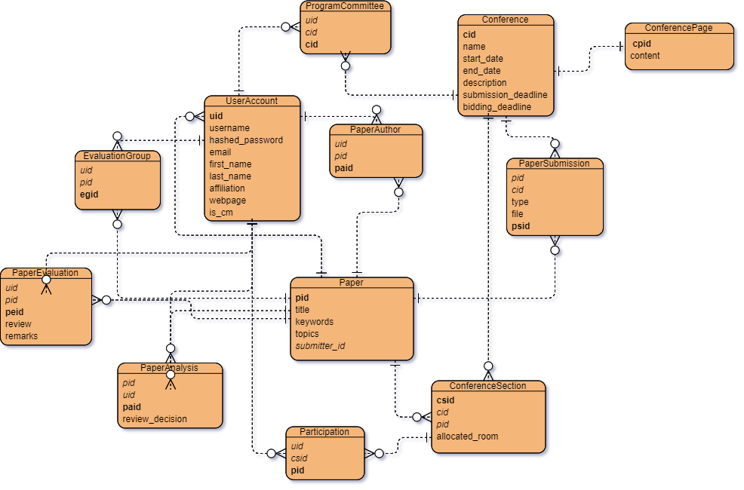

- creation of user accounts

- creation of conferences (draft)

- editing & managing conferences

- publishing conference pages

- submitting papers

- analyzing papers

- evaluating papers

- signing up to a conference section

2.4 OPERATING ENVIRONMENT

- **database**: central, SQL

- **operating** **system**: Windows

- **platform**: Java

- **ORM**: Hibernate

- **GUI framework**: JavaFX

2.5 DESIGN & IMPLEMENTATION CONSTRAINTS

- development must meet required deadline

- components must be rigorously tested

- developers must use the technologies specified in this document

2.6 ASSUMPTIONS & DEPENDENCIES

- venue related information specified by committee members is valid

- database host can support a reasonable amount of information regarding user & conference data

- no user moderation is required